ONLINE CULTURAL EXCHANGE

Dear participants,

This is the place where you can find some sugesstions and ressources to discover more information about the partners involved in our project, their activities, SSE or about our experimentation areas. We wish you a nice virtual travel! Enjoy!
Training team

GREECE:
https://www.staramaki.gr/en
Video for that practice ΚΟΙΝΣΕΠ Σταραμάκι (subtitles in enlgish)
https://www.youtube.com/watch?v=niVZUxepfNo&t=45s

ITALY:
Information from Como:
https://www.youtube.com/watch?v=WQ1L7lxS2qI&feature=youtu.be - touristic video of the city
https://www.facebook.com/enaipcantu/videos/2154430144689709 - presentation of the Vet course in bakery and pastry (the sector that we choose for our experimentation)
https://www.youtube.com/watch?v=pMmSElPOBGg - it's a project of an Hostel, financed by Banca Etica and linked with Vet trainees in touristic sector
https://www.facebook.com/lisolacheceCO/videos/961802207502713/ - this deal with the SSE Fair (16° edition)

These are from Bergamo:
https://www.youtube.com/watch?v=T7m1BE7wM6g - touristic video of the city
https://www.unibg.it/video/lemuradibergamoversounesco - this video talks about the story of the city and it was made for children by young people in university.
https://youtu.be/UV41MusbpUg - Monterosso Choir, Monterosso is a ‘quartiere’ in Bergamo where the SSE network organize a monthly local farmers’ market. Many singers here are part of a cultural association cooperating with the market organizers. This was a way to feel together one another despite the distance due to the lockdown.
General:
https://www.youtube.com/watch?v=rASj9loN0rk – this initiative deals with sustainable development through a social experiment. It's really nice and effective!
https://youtu.be/pTPt3h8OBMU - and here is “bella ciao” international, that probably everyone knows

FRANCE:
Here are graphic designs about "French clichés"

Here are graphic designs about "French clichés"..
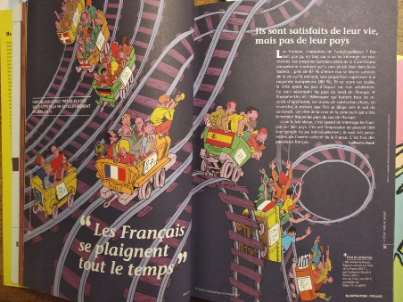
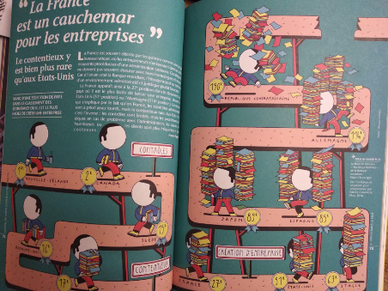
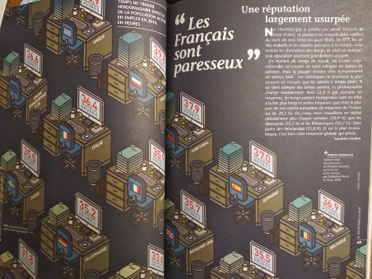

... and a link to a song that has been a friend during the first containment period, with lyrics translated below
https://www.youtube.com/watch?v=hMhnOHX69yY
This morning a very strange thing happened
The world has split up
I didn't see things as real anymore
The world has split up
I got scared, I screamed for help.
The world has split up

I welcomed a friend who took me in his arms.
And whispered to me
Look behind the clouds
There is always the azure blue sky
Who always comes to him as a friend
Reminding you quietly
That joy is always just around the corner

He told me to be patient
My friend, be patient
Towards a new shoreline
Your heart is carried away
The old territory lights you with its lighthouses
Lights you with its headlights

This morning a very strange thing happened
The world has split up
I felt the time split for a moment on the faces themselves.
The world has split up
Your bodies that I perceived only yesterday in their exactness
Lost their density

Look below the night
There is always the day that puts its lights
On a corner of the earth
Remembering you in a low voice
That joy is always just around the corner

GERMANY:
https://www.youtube.com/watch?v=0JwxrZO97vI&feature=youtu.be

PORTUGAL:
About ECP (local partner):
https://www.facebook.com/ecpescolacomercioporto/videos/2812831012294185/
https://www.facebook.com/155491247842410/videos/357102422231748/

About APDES:
https://www.youtube.com/watch?v=tO509cDkOTM&list=PLFZqHwKRAXHLuQwwadxaIuNXHoR76pkZ-

About Porto:
https://www.youtube.com/watch?v=fh8iw82U3Jw
https://www.youtube.com/watch?v=GLY5g8gvL_M
https://www.youtube.com/watch?v=i5me6UU04Bw

ROMANIA:
A short film about our training experience:
https://www.youtube.com/watch?v=IfLaOgUtqTo
LA PAS: Slow-Food Festival, Timisoara (2019):
https://www.youtube.com/watch?v=s80D7UlGoWs
Short videos about Timișoara
https://www.youtube.com/watch?v=qhuQ3qYa0HU
https://www.youtube.com/watch?v=YIstkqusezA
Maria Tanase: she is one of the most famous traditional Romanian singer.
https://www.youtube.com/watch?v=nH2VMA8hFjI

